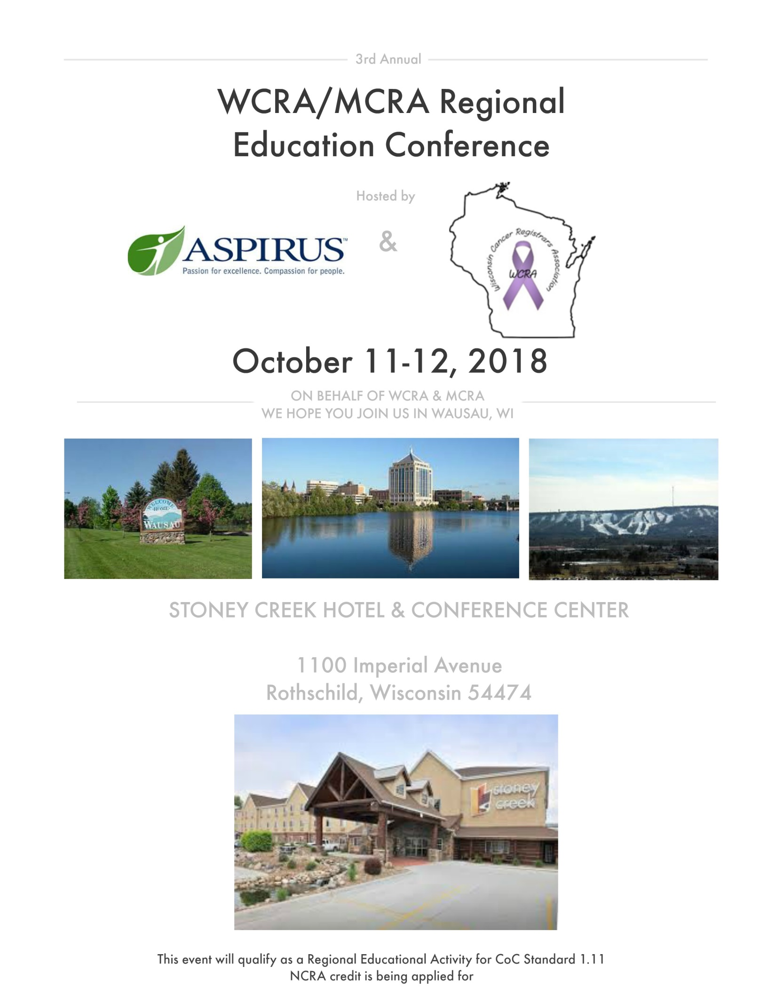

|  |  |  |  |
| --- | --- | --- | --- |
| **Day 1: Thursday, October 11** | | | |
| 7:00am | **Registration**  Northwoods Ballroom | | **Breakfast**  Northwoods Ballroom Foyer |
| 7:55am | **Welcoming Remarks**  Northwoods Ballroom | | |
| 8:00am – 9:00am | **Update on HPV Positive Head & Neck Cancers**  Christopher Platta, MD  Aspirus Regional Cancer Center  Northwoods Ballroom | | |
| 9:00am – 10:00am | **Emerging Topics in Cancer Care**  Christopher Peterson, MD  Aspirus Regional Cancer Center  Northwoods Ballroom | | |
| 10:00am – 10:15am | **Vendor Exhibits & Morning Break**  Northwoods Ballroom Foyer | | |
|  | **WCRA Track** | **MCRA Track** | |
| 10:15am – 11:15am | **Wisconsin State Updates**  Northwoods Ballroom | **Minnesota State Updates**  Timberlands Room | |
| 11:15am – 12:00pm | **WCRA Business Meeting**  Northwoods Ballroom | **MCRA Business Meeting**  Timberlands Room | |
| 12:00pm – 1:00pm | **Networking Lunch**  Northwoods Ballroom | | |
| 1:00pm – 2:30pm | **Grade & SSDI for 2018**  Louanne Currence, RHIT, CTR  A. Fritz and Associates, LLC  Northwoods Ballroom | | |
| 2:30pm – 2:45pm | **Vendor Exhibits & Afternoon Break**  Northwoods Ballroom Foyer | | |
| 2:45pm – 4:45pm | **Solid Tumor Rules**  Louanne Currence, RHIT, CTR  A. Fritz and Associates, LLC  Northwoods Ballroom | | |
| 5:00pm | **Social Hour**  *Presented by RegAssist*  Northwoods Ballroom | | |
| **Day 2: Friday, October 12** | | | |
| 7:00am | **Registration**  Northwoods Ballroom | | **Breakfast**  Northwoods Ballroom Foyer |
| 7:55am | **Welcoming Remarks**  Northwoods Ballroom | | |
| 8:00am – 10:00am | **Breast Cancer**  **Including: Solid Tumor Rules, SSDI & Exercise**  Louanne Currence, RHIT, CTR  A. Fritz and Associates, LLC  Northwoods Ballroom | | |
| 10:00am – 10:15am | **Vendor Exhibits & Morning Break**  Northwoods Ballroom Foyer | | |
| 10:15am – 11:15am | **2018 Staging/hot topic**  Louanne Currence, RHIT, CTR  A. Fritz and Associates, LLC  Northwoods Ballroom | | |
| 11:15am – 12:00pm | **2018 Staging/hot topic**  Louanne Currence, RHIT, CTR  A. Fritz and Associates, LLC  Northwoods Ballroom | | |
| 12:00pm – 1:00pm | **Networking Lunch**  Northwoods Ballroom | | |
| 1:00pm – 1:45pm | Image may contain: 4 people, people smiling, people standing and indoor**Dietary Needs of Cancer Patients**  Lisa Prell, MS, RD, CD  Aspirus Regional Cancer Center  Northwoods Ballroom | | |
| 1:45pm – 2:00pm | **Vendor Exhibits & Afternoon Break**  Northwoods Ballroom Foyer | | |
| 1:45pm – 2:45pm | Eric A Johnson MD**Endoscopic Ultrasound & Its Uses in Malignancy**  Eric Johnson, MD  Gastrointestinal Associates, S.C.  Northwoods Ballroom | | |
| 2:45pm – 3:00pm | **Vendor Exhibits & Afternoon Break**  Northwoods Ballroom Foyer | | |
| 3:00pm – 3:45pm | **Genetics of Breast Cancer; Going Beyond BRCA Mutations**  Rachel Hoyord, MS  Aspirus Genetics Program  Northwoods Ballroom | | |

**Conference Fees**

Early Bird Rate (7/1/18 – 7/27/18)

|  |  |  |  |
| --- | --- | --- | --- |
|  | Thursday & Friday | Thursday Only | Friday Only |
| WCRA/MCRA Member | $150 | $80 | $80 |
| Non-Member | $200 | $110 | $110 |
| Student | $90 | $50 | $50 |

Regular Rate (7/28/18 – 9/21/18)

|  |  |  |  |
| --- | --- | --- | --- |
|  | Thursday & Friday | Thursday Only | Friday Only |
| WCRA/MCRA Member | $175 | $100 | $100 |
| Non-Member | $225 | $120 | $120 |
| Student | $90 | $50 | $50 |

Rate after 9/21/18

|  |  |  |  |
| --- | --- | --- | --- |
|  | Thursday & Friday | Thursday Only | Friday Only |
| WCRA/MCRA Member | $200 | $120 | $120 |
| Non-Member | $250 | $130 | $130 |
| Student | $110 | $60 | $60 |

*Students cannot be currently working in the registry field and must show proof of enrollment in a RHIT/RHIA or CTR program with their registration to be eligible for the student rate. Please provide a photo copy of your student ID with year or enrollment or an unofficial transcript on school letterhead.

*Cancellation Policy: Cancellations must be received in writing by 9/21/18 to be eligible for a refund. WCRA will accept cancellations by mail or e-mail and will provide a refund to those received on or before 9/21/18. For cancellations received during the specified time period, the refund will be issued on the next business day after the last day of the conference. WCRA will refund the registration fees paid, less a $100 processing charge. No cancellations will be accepted for refund after 9/21/18. Attendee substitution is permitted.

**Registration**

Full name: __________________________________________________________________________________________________________________

Credentials: _________________________________________________________________________________________________________________

Employer: ___________________________________________________________________________________________________________________

Address: ____________________________________________________________________________________________________________________

City/State/Zip: _____________________________________________________________________________________________________________

Phone: ______________________________________________________________________________________________________________________

Email: _______________________________________________________________________________________________________________________

Emergency Contact/Phone: _________________________________________________________________________________________________

Dietary Concerns: ___________________________________________________________________________________________________________

**Registration is due by September 21, 2018 (see rates).**

Please make all checks payable to WCRA

Mail registration and payment to:

Samantha Reynolds, CTR

Cancer Registry Department

Aspirus Regional Cancer Center

215 N. 28th Ave.

Wausau, WI 54401

**Lodging**

Stoney Creek Hotel & Conference Center

1100 Imperial Ave

Rothschild, WI 54474

715-355-6858

[www.stoneycreekhotels.com](http://www.stoneycreekhotels.com)

Rates:

Double $75.00/night

King $75.00/night

*Plus tax. Includes Wi-Fi and breakfast both mornings.

A block of rooms is being held for WCRA until 9/10/18.

Individuals will need to call to make a reservation and mention the WCRA/MCRA conference.

*Should the rooms fill at Stoney Creek Hotel and additional rooms would be needed, the Stoney Creek Hotel has agreed to block rooms at the Grand Lodge Hotel & Waterpark for the same nightly rate. Rooms will need to be completely filled at Stoney Creek Hotel before rooms at the Grand Lodge will be granted.

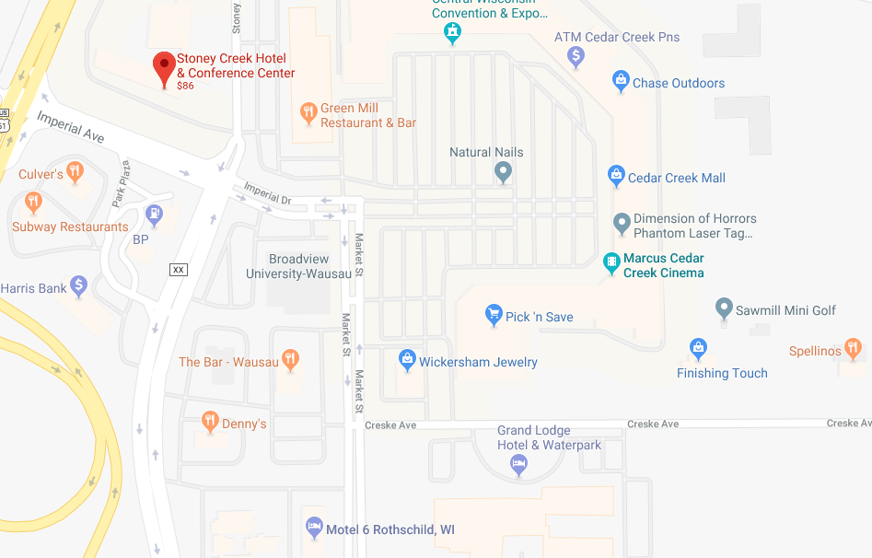**Local Spots**

SHORT DRIVING DISTANCE

»Restaurants

Sam’s Pizza

Olive Garden

Texas Roadhouse

Pizza Ranch

Basil

Sconni’s Alehouse & Eatery

Dunkin’ Donuts

Brews Brothers

»Shopping

Target

Walgreens

Walmart

Kohl’s

TJ Maxx

Hobby Lobby

Old Navy

Sam’s Club

Shopko

»Miscellaneous

Nicolet Bank

Covantage Credit Union

BMO Harris Bank

People’s State Bank

IGA grocery story

WALKING DISTANCE

»Restaurants

The Bar

Green Mill

Culver’s

Subway

Arby’s

Denny’s

»Miscellaneous

Pick ‘n Save grocery store

BMO Harris Bank/ATM

Planet Fitness

Marcus Theaters Movie Theater

**Vendors**

If you are interested in a vendor table for the 2018 conference, please email Samantha Reynolds at [samantha.reynolds@aspirus.org](mailto:samantha.reynolds@aspirus.org). A vendor contract will be provided and $400 vendor fee will be due at the time of contract completion.